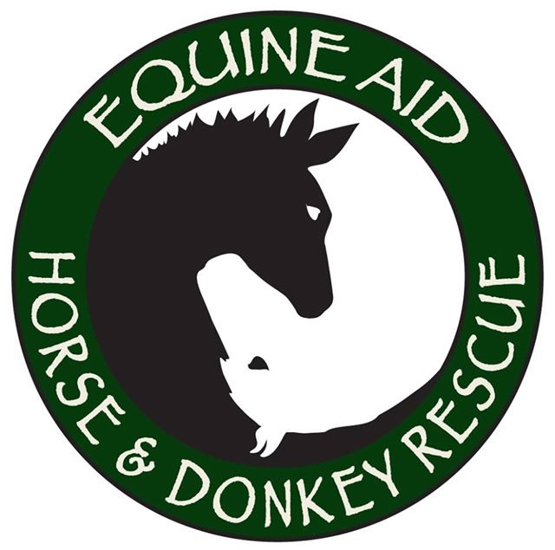
Adoption Agreement
Equine Aid Horse and Donkey Rescue

I, ___________________________________, commit to adopting and caring for the following equine: ________________________ Brand/Microchip: _______________
Breed:__________________ Gender: ___ Age/Birthdate: ________ Height: ______ Color and Markings: _____________________________________________________
Adopter Address: _______________________________________________________
Location where equine will be housed: ______________________________________
Home Phone: ______________________ Cell Phone:__________________________ Email: __________________________________________________________________
Date: __________________________ Adoption Fee: ______________

All of the information I have given above is true and complete. I understand that it is my responsibility to evaluate this horse for myself before agreeing to adopt it. Equine Aid is in no way responsible for any damage, accident, or injury resulting from the placement of any equine.

I have been given a copy of and am in full agreement with the following terms and conditions. I promise to abide by these terms for the lifetime of the equine that I am adopting:

******PLEASE INITIAL EACH NUMBER*******
- I release Geri Vincent, Doug Arneson, Equine Aid and all of its members, agents and employees from all liabilities of any kind or character for loss, damage, injury, or death.
- I will keep the equine in a safely fenced area; provide proper and sufficient food, water, shelter, grooming and humane treatment at all times.
- I will provide necessary vaccinations, worming and dental care as recommended by an equine veterinarian. I will procure veterinary treatment if the Equine becomes sick or injured. Hoof trimming will be done every four to eight weeks
- In the event that I cannot continue to provide a home for this horse, I will contact Geri Vincent or Equine Aid before rehoming, giving away, or selling the horse/donkey. If I am unable to keep this equine, it will be returned to Equine Aid Rescue. If the equine requires euthanasia, an equine veterinarian must provide documentation.
- This equine may not be bred. If, under any circumstances, this equine is bred, Equine Aid may take immediate possession of the equine.
- Equine Aid staff reserves the right to visit this animal at any time.

Adopter Signature(s): ___________________________________________________
Print Name(s): __________________________________________________________
Signature of Equine Aid representative: ____________________________________

Equine Aid Horse and Donkey Rescue
Mail: PO Box 123 Monroe, WA 98272
Farm Address: 11726 257th Ave SE Monroe, WA 98272
Rescue Phone: 360-282-6667
Emergency Phone: 206-235-6059

Veterinary records are provided including current diet.

